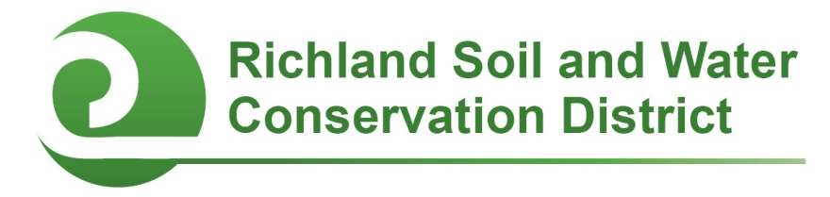
2014-2015 Richland County Conservation Teacher of the Year
Nomination Form

Eligibility: Teachers at any public, private, or alternative school in Richland County are eligible to receive this award. Prior winners are eligible to receive the award a second time. Self-nominations and nominations from individuals or groups who are familiar with the teacher’s activities related to this award are all acceptable. Nominations must be postmarked or received electronically by April 3, 2015.

Teacher’s name:

Teacher’s position (grade and subject):

Teacher’s e-mail address: Teacher’s phone:

School: School phone:

Nominator’s name and position (if not a self-nomination):

Nominator’s e-mail address: Nominator’s phone:

Justification (please respond on a separate page or pages):

- Describe the nominee’s involvement in school conservation projects and environmental education initiatives.
- Describe student learning outcomes resulting from these projects.
- List any grants, awards, or other forms of recognition this teacher has earned for his/her conservation efforts.
- List conservation-related professional development opportunities the nominee has pursued (courses, workshops, trainings, etc.).

Optional Supporting Materials: You are welcome but not required to submit photographs (with captions), letters of support, or other materials demonstrating why this teacher deserves to be the Richland County Conservation Teacher of the Year.

Send nomination form and any optional supporting materials to:

Richland Soil and Water Conservation District
2020 Hampton Street, Room 3063A
Columbia, SC 29204
Fax: (803) 576-2088
E-mail: fisherc@rcgov.us
Phone: (803) 576-2080

Nominations must be postmarked or submitted electronically by April 3, 2015.

2014-2015 Richland County Conservation Principal of the Year
Nomination Form

Eligibility: Principals of any public, private, or alternative school in Richland County are eligible to receive this award. Prior winners are eligible to receive the award a second time. Self-nominations and nominations from individuals or groups who are familiar with the principal’s activities related to this award are all acceptable. Nominations must be postmarked or received electronically by April 3, 2015.

Principal’s name:

Principal’s e-mail address:

School: School phone:

Number of students:

Nominator’s name and position (if not a self-nomination):

Nominator’s e-mail address: Nominator’s phone:

Questions (please respond on a separate page or pages):

- What conservation projects and environmental education initiatives are active or have been completed at the nominee’s school in the 2014-2015 school year?
- How does the nominee support these projects?

Optional Supporting Materials: You are welcome but not required to submit photographs (with captions), letters of support, or other materials demonstrating why your principal deserves to be the Richland County Conservation Principal of the Year.

Send nomination form and any optional supporting materials to:

Richland Soil and Water Conservation District
2020 Hampton Street, Room 3063A
Columbia, SC 29204
Fax: (803) 576-2088
E-mail: fisherc@rcgov.us
Phone: (803) 576-2080

Nominations must be postmarked or submitted electronically by April 3, 2015.

